Alexander Baldree, Jordan Dardar, Max Jankowski, Aftabur Rahman
Bellevue University
08/13/26
CSD460 Module 1 Purpose

Purpose 1.1
The purpose of the Moffat Bay Marina website is to create a central online location where customers can easily learn about the marina and the services available to them before they plan their visit. Our goal is to make the site simple to navigate and easy to understand so customers can quickly find information about docking options, marina services, nearby attractions, and other important details. We want the website to give customers enough useful information to help them decide if Moffat Bay Marina fits their needs without having to search through multiple different sources.
In sight of the site, we want to give customers an easy way to manage the important parts of their visit online. We are developing the website so customers can create an account, log in, provide information about their boat, choose arrival and departure dates, and complete a marina reservation. Customers will also be able to return later and look up their reservation information when needed. By combining information, account features, and reservation tools into one website, our goal is to create a system that helps customers learn about Moffat Bay Marina, plan their trip, and manage their reservation from one convenient place.

Terminology 1.2:
Moffat Bay Marina:
The marina facility located at Moffat Bay on Joviedsa Island.
User:
Anyone who visits the Moffat Bay Marina website.
Customer:
A person who uses the website to learn about the marina or reserve a marina slip.
Registered User:
A customer who has created an account with Moffat Bay Marina.
Authentication:
The process of verifying that a customer's login credentials are correct.
Registration:
The process of creating a new customer account.
Login:
The process where an existing customer enters their username or email address and password to access their account.
Marina Slip:
A designated location within the marina where a customer's boat can be docked.
Reservation:
A record containing the customer's requested dates, boat information, marina slip information, and other details associated with their stay.
Boat Information:
Information about the customer's boat, such as the boat name, type, length, or other information needed to determine the appropriate marina space.
Check-In Date:
The date the customer plans to arrive at Moffat Bay Marina.
Check-Out Date:
The date the customer plans to leave the marina.
Reservation Confirmation:
The step where the customer reviews the entered information and confirms that they want to make the reservation.
Reservation Lookup:
A page that allows registered customers to locate and view previously submitted reservation information.
Database:
The system used to permanently store registered users and reservation records.
Primary Key:
A unique value used by the database to identify an individual record.
Foreign Key:
A value used to connect related information between database tables.
Session:
A way for the website to remember that a customer has successfully logged in while they move between different pages.

User Personas 1.3:
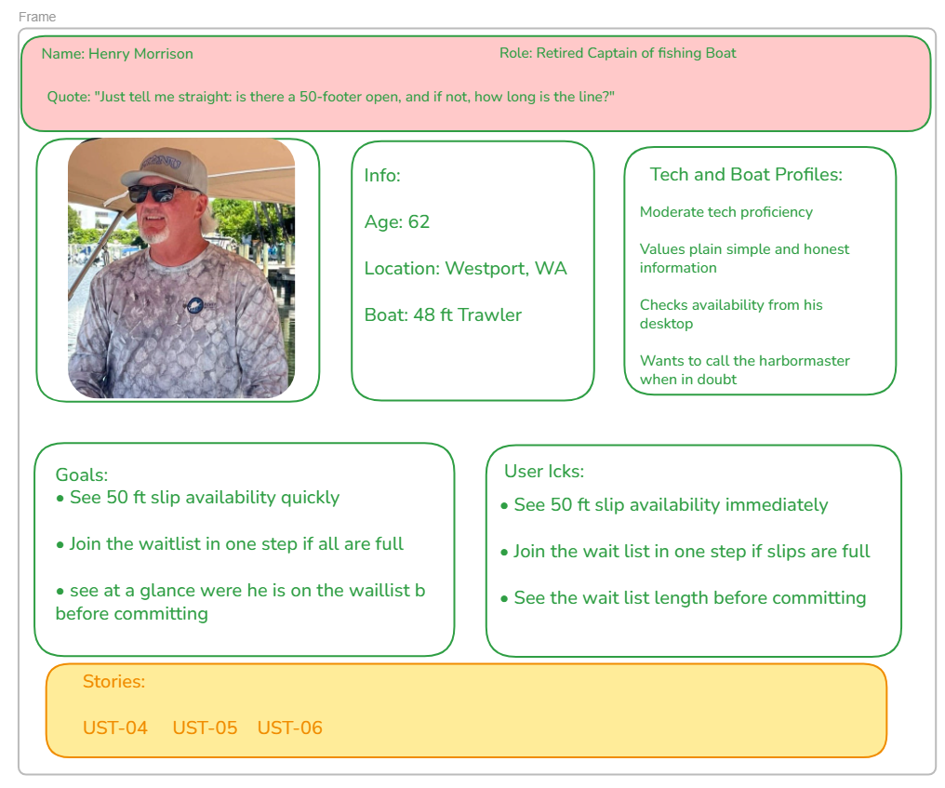
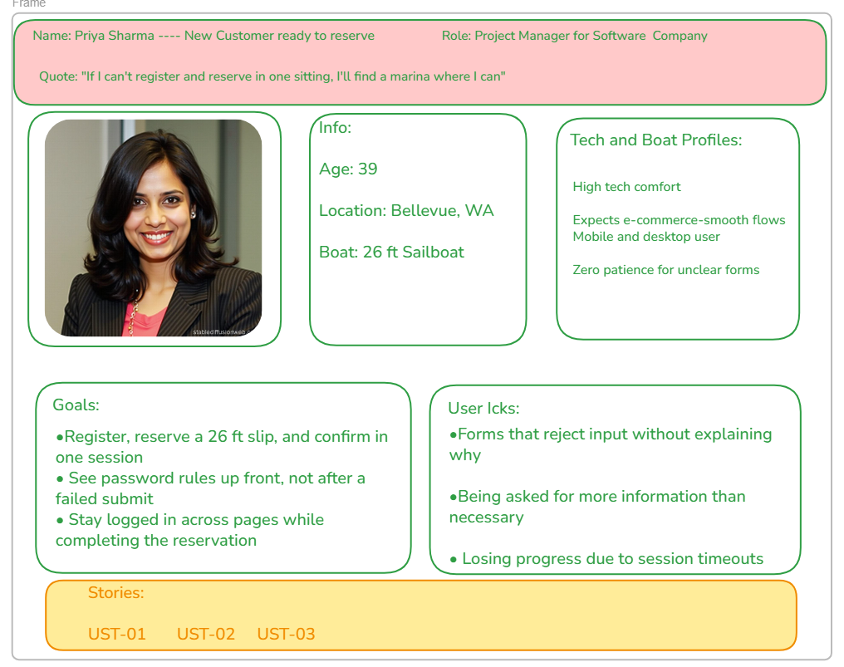
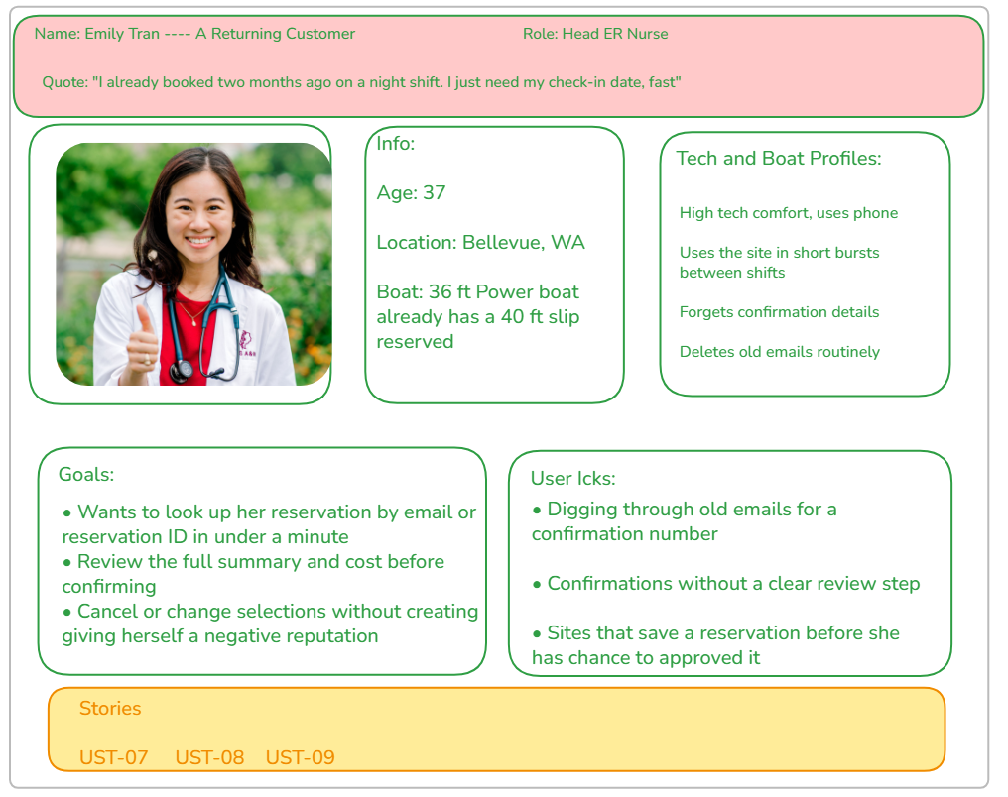

User Stories 1.4:
UST-01: Before I sign up, I want to be able to view the full site without signing up to better evaluate the marina. I want to be able to contact people if I have questions.
UST-02: As a possible new customer, I want information on the slip pricing formula, a general 10/ft + 10 Elec is great, but I want to know what my cost is before providing my info.
UST-03: As a new customer, I want an easy sign-up that includes my info with boat information. I want a single signup and reservation page.
UST-04: As a customer looking to sign up and want an easy-to-follow email verification. I want to be sure that my info is secure and have channels to inform me if something fish happened to my account.
UST-05: As a customer whose boat slip sizes are not available at the moment, I want to be informed that these slips are not available and have a clear path to sign up for the waitlist.
UST-06: As a customer who’s size slip is not available, I want to know how many people are ahead of me so I can decide whether to join the waitlist.
UST-07: As I signed up client, I want a detailed summary of my reservation. This should include my boat info, slip size, slip number, check-in date and total cost for the time reserved.
UST-08: As a returning customer, let me see my reservation ID along with all information about times I had reserved in the past. This should include checking in dates and slips I used so I can log my details.
UST-09: As a returning customer, I want to have the ability to cancel my reservation from the summery page. I then want to be returned to the reservation page where I can make a new reservation without it affecting my log information.

1.5 Work Estimations (To-Do List)
Purpose
This section translates the team's nine existing user stories (UST-01 through UST-09) into prioritized development work, estimated hours, and actionable To-Do tasks for the Moffat Bay Tasks Kanban board. The estimates are proposed planning estimates and should be reviewed by Group Green using Planning Poker.

Prioritized User Stories and Total Estimated Hours
Priority | User Story | Description | Total Hours
1 | UST-03 | Easy sign-up including customer and boat information | 8
2 | UST-05 | Unavailable slip notification and waitlist process | 8
3 | UST-07 | Detailed reservation summary | 6
4 | UST-04 | Email verification and account security | 7
5 | UST-08 | Reservation lookup and history | 5
6 | UST-09 | Reservation cancellation | 4
7 | UST-01 | Public website access and contact information | 4
8 | UST-02 | Slip pricing information | 3
9 | UST-06 | Waitlist position/count | 3
Total Proposed Effort |  | Hours
All nine user stories |  | 48

Detailed Work Breakdown – Individual User Story Tables
Each user story is presented in its own separate table below. Each table has its own task breakdown and its own total estimated hours. This format makes the work easier to review and transfer to the Kanban board.
User Story | Description
UST-01 – Public Website Access and Contact Information | The customer wants to view the full site without signing up and have a way to contact the marina.
To-Do Task | Story Hours
Create landing page structure and navigation | 1.0
Create marina About Us/information content | 1.0
Create Contact Us page and contact information | 1.0
Test public pages without requiring login | 1.0
TOTAL ESTIMATED HOURS | 4.0

User Story | Description
UST-02 – Slip Pricing Information | The customer wants to understand the slip pricing formula and estimate cost before providing personal information.
To-Do Task | Story Hours
Add monthly slip pricing information | 0.75
Document the $10 per foot plus $10 electric formula | 0.50
Create/display example cost calculation | 0.75
Test pricing examples and displayed information | 1.0
TOTAL ESTIMATED HOURS | 3.0

User Story | Description
UST-03 – Easy Sign-Up Including Boat Information | The customer wants an easy sign-up that includes personal and boat information in a single sign-up and reservation flow.
To-Do Task | Story Hours
Create registration/reservation form layout | 1.0
Add customer information fields | 1.0
Add boat name and boat length fields | 1.0
Add email and password validation | 1.0
Create/store customer account information | 1.5
Create/store boat information | 1.0
Connect registration information to reservation process | 1.0
Test registration and boat-information workflow | 0.5
TOTAL ESTIMATED HOURS | 8.0

User Story | Description
UST-04 – Email Verification and Account Security | The customer wants an easy-to-follow email verification process and secure account information.
To-Do Task | Story Hours
Create login/authentication workflow | 1.0
Implement email-format validation | 0.75
Implement email verification workflow | 1.5
Implement password security requirements | 1.0
Implement secure password storage | 1.0
Create session management | 1.0
Test authentication and verification scenarios | 0.75
TOTAL ESTIMATED HOURS | 7.0

User Story | Description
UST-05 – Slip Availability and Waitlist | When the required slip size is unavailable, the customer should be informed and given a clear path to join the waitlist.
To-Do Task | Story Hours
Determine required slip size from boat length | 1.0
Create/check slip availability logic | 1.5
Connect available slips to reservation process | 1.0
Display unavailable-slip notification | 0.5
Create waitlist option | 1.0
Store waitlist request | 1.0
Cancel reservation attempt when no slip is available | 0.5
Test available, unavailable, and waitlist scenarios | 1.5
TOTAL ESTIMATED HOURS | 8.0

User Story | Description
UST-06 – Waitlist Position/Count | The customer wants to know how many people are ahead of them before deciding whether to join the waitlist.
To-Do Task | Story Hours
Retrieve current waitlist count for slip category | 1.0
Calculate/display number of customers ahead | 1.0
Display waitlist position before commitment | 0.5
Test waitlist count and position scenarios | 0.5
TOTAL ESTIMATED HOURS | 3.0

User Story | Description
UST-07 – Detailed Reservation Summary | The customer needs a reservation summary containing boat information, slip size, slip number, check-in date, and total cost.
To-Do Task | Story Hours
Create reservation summary page | 1.0
Display boat information | 0.5
Display assigned slip size | 0.5
Display slip number | 0.5
Display check-in date | 0.5
Calculate/display total cost | 1.0
Add confirm reservation functionality | 0.75
Add cancel functionality | 0.75
Test reservation summary | 0.5
TOTAL ESTIMATED HOURS | 6.0

User Story | Description
UST-08 – Reservation Lookup and History | A returning customer wants to see reservation IDs and information about previous reservations, including dates and slips used.
To-Do Task | Story Hours
Create reservation lookup page/form | 1.0
Implement reservation ID search | 0.75
Implement email-based search | 0.75
Retrieve reservation history from database | 1.0
Display reservation dates and slip information | 1.0
Test lookup and history results | 0.5
TOTAL ESTIMATED HOURS | 5.0

User Story | Description
UST-09 – Reservation Cancellation | A returning customer wants to cancel a reservation from the summary page and return to the reservation page without negatively affecting the reservation history.
To-Do Task | Story Hours
Add cancellation control to reservation summary | 0.5
Implement reservation cancellation logic | 1.0
Update reservation status/availability | 1.0
Return customer to reservation page | 0.5
Verify reservation history remains accurate | 0.5
Test cancellation scenarios | 0.5
TOTAL ESTIMATED HOURS | 4.0

Kanban To-Do List
The following are the actionable tasks to provide to the team leader/delegate for the Moffat Bay Tasks Kanban board.
User Story | Kanban Task |  | Hours
UST-01 – Public Website Access and Contact Information | Create landing page structure and navigation |  | 1.0
UST-01 – Public Website Access and Contact Information | Create marina About Us/information content |  | 1.0
UST-01 – Public Website Access and Contact Information | Create Contact Us page and contact information |  | 1.0
UST-01 – Public Website Access and Contact Information | Test public pages without requiring login |  | 1.0
User Story Total |  | Total Hours
UST-01 – Public Website Access and Contact Information |  | 4.0

User Story | Kanban Task |  | Hours
UST-02 – Slip Pricing Information | Add monthly slip pricing information |  | 0.75
UST-02 – Slip Pricing Information | Document the $10 per foot plus $10 electric formula |  | 0.50
UST-02 – Slip Pricing Information | Create/display example cost calculation |  | 0.75
UST-02 – Slip Pricing Information | Test pricing examples and displayed information |  | 1.0
User Story Total |  | Total Hours
UST-02 – Slip Pricing Information |  | 3.0

User Story | Kanban Task |  | Hours
UST-03 – Easy Sign-Up Including Boat Information | Create registration/reservation form layout |  | 1.0
UST-03 – Easy Sign-Up Including Boat Information | Add customer information fields |  | 1.0
UST-03 – Easy Sign-Up Including Boat Information | Add boat name and boat length fields |  | 1.0
UST-03 – Easy Sign-Up Including Boat Information | Add email and password validation |  | 1.0
UST-03 – Easy Sign-Up Including Boat Information | Create/store customer account information |  | 1.5
UST-03 – Easy Sign-Up Including Boat Information | Create/store boat information |  | 1.0
UST-03 – Easy Sign-Up Including Boat Information | Connect registration information to reservation process |  | 1.0
UST-03 – Easy Sign-Up Including Boat Information | Test registration and boat-information workflow |  | 0.5
User Story Total |  | Total Hours
UST-03 – Easy Sign-Up Including Boat Information |  | 8.0

User Story | Kanban Task |  | Hours
UST-04 – Email Verification and Account Security | Create login/authentication workflow |  | 1.0
UST-04 – Email Verification and Account Security | Implement email-format validation |  | 0.75
UST-04 – Email Verification and Account Security | Implement email verification workflow |  | 1.5
UST-04 – Email Verification and Account Security | Implement password security requirements |  | 1.0
UST-04 – Email Verification and Account Security | Implement secure password storage |  | 1.0
UST-04 – Email Verification and Account Security | Create session management |  | 1.0
UST-04 – Email Verification and Account Security | Test authentication and verification scenarios |  | 0.75
User Story Total |  | Total Hours
UST-04 – Email Verification and Account Security |  | 7.0

User Story | Kanban Task |  | Hours
UST-05 – Slip Availability and Waitlist | Determine required slip size from boat length |  | 1.0
UST-05 – Slip Availability and Waitlist | Create/check slip availability logic |  | 1.5
UST-05 – Slip Availability and Waitlist | Connect available slips to reservation process |  | 1.0
UST-05 – Slip Availability and Waitlist | Display unavailable-slip notification |  | 0.5
UST-05 – Slip Availability and Waitlist | Create waitlist option |  | 1.0
UST-05 – Slip Availability and Waitlist | Store waitlist request |  | 1.0
UST-05 – Slip Availability and Waitlist | Cancel reservation attempt when no slip is available |  | 0.5
UST-05 – Slip Availability and Waitlist | Test available, unavailable, and waitlist scenarios |  | 1.5
User Story Total |  | Total Hours
UST-05 – Slip Availability and Waitlist |  | 8.0

User Story | Kanban Task |  | Hours
UST-06 – Waitlist Position/Count | Retrieve current waitlist count for slip category |  | 1.0
UST-06 – Waitlist Position/Count | Calculate/display number of customers ahead |  | 1.0
UST-06 – Waitlist Position/Count | Display waitlist position before commitment |  | 0.5
UST-06 – Waitlist Position/Count | Test waitlist count and position scenarios |  | 0.5
User Story Total |  | Total Hours
UST-06 – Waitlist Position/Count |  | 3.0

User Story | Kanban Task |  | Hours
UST-07 – Detailed Reservation Summary | Create reservation summary page |  | 1.0
UST-07 – Detailed Reservation Summary | Display boat information |  | 0.5
UST-07 – Detailed Reservation Summary | Display assigned slip size |  | 0.5
UST-07 – Detailed Reservation Summary | Display slip number |  | 0.5
UST-07 – Detailed Reservation Summary | Display check-in date |  | 0.5
UST-07 – Detailed Reservation Summary | Calculate/display total cost |  | 1.0
UST-07 – Detailed Reservation Summary | Add confirm reservation functionality |  | 0.75
UST-07 – Detailed Reservation Summary | Add cancel functionality |  | 0.75
UST-07 – Detailed Reservation Summary | Test reservation summary |  | 0.5
User Story Total |  | Total Hours
UST-07 – Detailed Reservation Summary |  | 6.0

User Story | Kanban Task |  | Hours
UST-08 – Reservation Lookup and History | Create reservation lookup page/form |  | 1.0
UST-08 – Reservation Lookup and History | Implement reservation ID search |  | 0.75
UST-08 – Reservation Lookup and History | Implement email-based search |  | 0.75
UST-08 – Reservation Lookup and History | Retrieve reservation history from database |  | 1.0
UST-08 – Reservation Lookup and History | Display reservation dates and slip information |  | 1.0
UST-08 – Reservation Lookup and History | Test lookup and history results |  | 0.5
User Story Total |  | Total Hours
UST-08 – Reservation Lookup and History |  | 5.0

User Story | Kanban Task |  | Hours
UST-09 – Reservation Cancellation | Add cancellation control to reservation summary |  | 0.5
UST-09 – Reservation Cancellation | Implement reservation cancellation logic |  | 1.0
UST-09 – Reservation Cancellation | Update reservation status/availability |  | 1.0
UST-09 – Reservation Cancellation | Return customer to reservation page |  | 0.5
UST-09 – Reservation Cancellation | Verify reservation history remains accurate |  | 0.5
UST-09 – Reservation Cancellation | Test cancellation scenarios |  | 0.5
User Story Total |  | Total Hours
UST-09 – Reservation Cancellation |  | 4.0

Planning and Estimation Note
Item | Statement
Estimate status | The hour values are proposed estimates based on the team's existing UST-01 through UST-09. They are not instructor-provided values.
Team review | Group Green should review and approve or adjust the estimates using Planning Poker before final submission.
Kanban | The approved tasks should be added to the Moffat Bay Tasks Kanban board by the team leader or delegate.
Prepared for CSD 460 Module 1 – Assignment 2 | Group Green

